Error: Reference source not found
–Flight Ticket Booking Portal
Author: NADIN
Date: April 6, 2024

1. Objective and Scope 3
2. Project End Users 3
3. Specific Requirements 4
3.1 Functional Requirements 4
3.2 Non Functional requirements 4
4. Flow chart 5
5. Use Case Diagram 6
6. Features …………………………………………………………………………………………………………. 6

4. Report 7

Objective and Scope
The objective of the Flight Ticket Booking Portal is to provide a user-friendly, efficient, and secure platform for customers to search for flights, compare prices, book tickets, manage their bookings, and check flight status.
The scope of the product includes the following basic features:
- The portal will allow users to search for flights based on various parameters such as departure and arrival locations, dates, number of passengers, etc.
- The portal will provide a feature to compare prices of different flights, helping users to make an informed decision.
- The portal will provide options for users to manage their bookings, including viewing, modifying, and canceling tickets
- Users will be able to check the real-time status of their flights.
- Users will be able to book flight tickets through a secure payment gateway.
- Reports

Project End Users
The project end users of this flight ticket booking portal is individual customers travel agencies, Businesses, and other B2B clients.

Specific Requirements:
- Functional Requirements:
Searching Flights: Users should be able to search for flights by entering their travel details such as departure city, destination city, date of travel, and number of passengers
Compare Prices: The portal should display a list of available flights along with their prices, allowing users to compare and choose the most suitable option.
Book Tickets: Users should be able to book tickets by providing their personal and payment details. After selecting the flight users can book tickets by providing passenger details and making a payment.
Manage Booking: Users should be able to view, modify, or cancel their bookings.
- Non-Functional Requirements:
Security: The portal should ensure secure transactions and protect users personal and payment information.
Performance: The portal should provide quick response times and be capable of handling multiple simultaneous users.
Usability: The portal should be user-friendly with an intuitive interface.
Compatibility: The portal should be compatible with various devices and browsers and the system should be scalable according to number of users entering into it
System constraints: The portal requires an internet connection and relies on APIs for flight data and payment processing. The system should be reliable and provide an accurate up to date flight information’s

Flow chart:
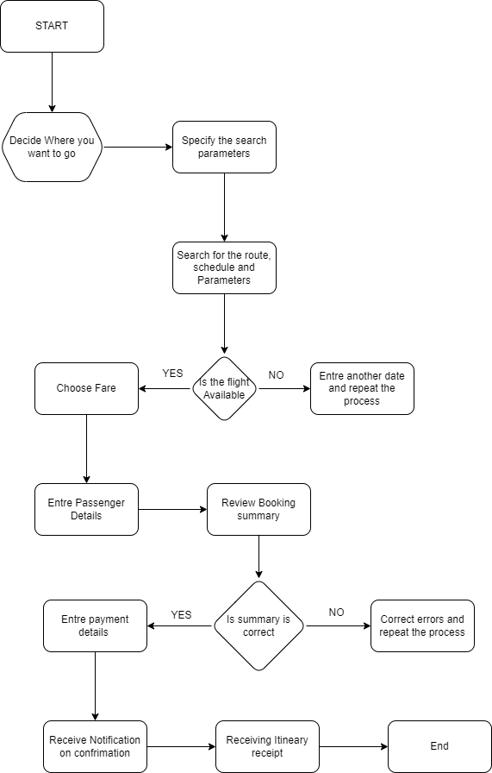

Use Case Diagram:

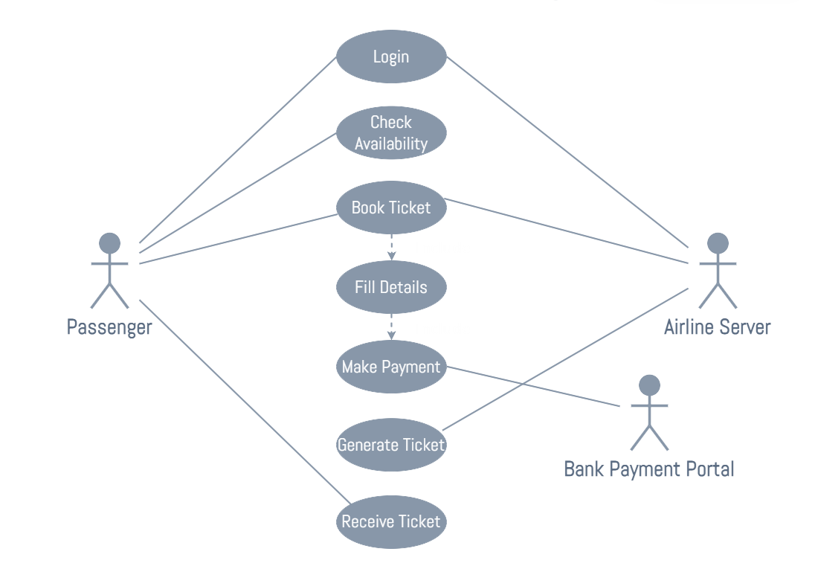

Features:
Price alerts: Users can set up a price alert for a specific route and get notified when the price drops
Points scheme: Frequent flyers earn points that can be redeemed for discounts or free tickets.
Seat selection: according to the availability user can choose their preferred seats during booking their flights
In flight services: user can pre select the in-flight services like meals / extra baggage and others, complements
Multi language support: The portal supports multiple languages for global accessibility.

Report:
This SRS provides a standard level view of the Flight Ticket Booking Portal. The next steps would include further detailing of requirements, followed by the design and implementation phases.

